**Shri Shivaji Vidya Prasarak Sanstha's**

**P.R.Ghogrey Science College,**

**Deopur Dhule**



**A PROJECT REPORT ON**

**Digital Driving School**

**SUBMITTED BY**

Kavita Pandurang Patil

**GUIDED BY**

Prof.Dr. Swati.Patil

***IN PARTIAL fulfillment of DEGREE OF***

**Master Of Computer Science**

**K.B.C.NORTH MAHARASHTRA UNIVERSITY, JALGAON**

**(2020-2021)**

**Shri Shivaji Vidya Prasarak Sanstha’s**

**Late Karmveer Dr.P.R.Ghogrey**

**Science College, Dhule (M.S.)**

Tel. & Fax : 02562-272562, E-Mail : ssvpprgsc@rediffmail.com

Web Site : www.ssvpsciencecollege.com

**Principal : Dr.M.V.Patil** ***M.Sc., Ph.D.***

Date :



*UGC Honoured*

***College With Potential For Excellence***

Outward No:

**Department of Computer Science**

**This is to certify that Miss kavita Pandurang Patil** **a final year student of Master of Computer Science (M.Sc.) of S.S.V.P.S. L.k.Dr.P.R.Ghogrey Science College, Dhule, has successfully completed the project entitled “Digital Driving School” under the guidance of Prof.Swati Patil during the semester-IV 2020-21.**

**Project Guide name. Head of department**

**(Prof.Dr.swati.patil) (Prof.Dr.S.N.Kotakar)**

**Principal**

**(Prof.M.V.Patil)**

**External-1 External-2**

**Shri Shivaji Vidya Prasark Sansta's late karmveer Dr.P.R.Ghogrey.Science Collage,Dhule(Maharashtra)**



**Acknowledgement**

It is with great pleasure and effort that I am able to present this project report. I have tried my best that makes it complete in all respect. I would like to take opportunity to give thanks to those peoples who help me directly or indirectly during the completion of this project.

I take this opportunity to express my deep sense of gratitude towards the great help,

which I have received from my project guide **Prof. Swati Patil,** during the course of develop

of my project titled “Digital Driving School”. I am also very much thankful to our

Head of the Department Dr. Prof. S. N. Kotkar whose constant support and interest

which lead me to the completion of my project.

I would like to mention my special thanks to all my faculty members of S.S.V.P.S. collage and all my friends who have contributed me much to complete this project.

Finally I would like to convey my regards to my family members specially my parent whose emotional support is always with me during this project.

Thanking you all.

Yours sincerely

Kavita patil

**INDEX**

* **Table of Content : -**

|  |  |  |
| --- | --- | --- |
| **Chapter No.** | **Chapter Name** | **Page no.** |
| **I** | **Abstract** |  |
| **II** | **List of Figures** | 7 |
| **1** | **Introduction** | 9 |
| **2** | **Fesability Study** | 12 |
| **3** | **Technolgy Used** | 15 |
| **4** | **Preliminary Design** | 21 |
| **5** | **Detailed Design** | 26 |
| **6** | **System Testing** | 30 |
| **7** | **Screen Shorts and Application Interface** | 33 |
| **8** | **Implementation** | 41 |
| **9** | **Concluding remark** | 44 |

**Abstract :-** The project deals with all the activities done by a car driving school such as a student registration with the rapid development of informational construction.higher request is needed by the management of driving, training enterprise driving training school effective management can reduce the waste of human power and wealth very much and ensure driving training school information resource to be utilized effectively as the human power and information become deeper and weeper.the management and share of driving training school manager vehicle and student become more and more important.

**Platform :- Windows**

**List of Figures :-**

|  |  |
| --- | --- |
| **Caption** | **Page no** |
| **ER Diagram** | **2**6 |
| **Zero level or context level diagram** | **28** |

**CHAPTER 1**

**Introduction**

**1.1 Introduction:-**

“Digital Driving School”

This Advanced Motor Driving School Management system can reduce the efforts of human power and wealth very much, and ensure driving-training school’s information resource to be utilized effectively. The motor driving trainers has to handle several students at a time. This will provide drawback in terms of communicating with students for his or her driving category schedule or test . it is a web- based application for maintaining records of car and scooty training school. his application automates manual tasks by managing all records of student’s admission, Attendance, vehicles and trainers. It will maintain the record of entire students of driving school. Admin is having control overall modules of the system. Two admins are assigned for the system. Two admins are assign for the work in the absence one, another can handle the process. Each student is provided a unique user id and password. They can login into the driving school management system with this id and password. After logging they will see basic training tutorials accessible on the portal. Students are also divided into two types, local student and remote students. Local student can registered and selected the package and timing, for remote student they can check for the nearby remote trainer.

**Objectives**

* The system should have a login. A login box should appear when the system is invoked.
* The Admin should have all the type of authority.
* The Admin should maintain property .Admin identify property type as it is residential or commercial property.
* The Admin user can inform their agents for regarduing to property and update the information regarding property and cancellation of property or changing buyer choice.
* The user should book the property for sell or rent with detail of property.
* The system is very useful for the companies or builders that can post and edit thear properties and their personal info and admin can monitor records of all of them.
* The system is also useful which also keeps track of Account details of buyers and Investors and also RES Industry.

**CHAPTER 2**

**Feasibility Study**

* 1. **Feasibility study**
* **Introduction :-**

1. Feasibility study is conducted to select the best solution from the various alternatives. The selection should meet the requirement & should meet the system requirement should be able to perform well.
2. The system required performance is defined by a statement of constraints, identification of system objective and description of output.

* **Need For Feasibility Study :-**
* Answer the question whether a new system is to be installed or not?
* Determine the potential of the existing system.
* Improve the existing system.
* Know what should be embedded in the new system.
* Define the problem and objective involved in a project.
* Avoid costly repairs at a later stage when the system is implemented.
* **Type Of Feasibility Study: -**
* Technical feasibility.
* Economic feasibility
* Operational feasibility of the project and
* Social Feasibility.

**1) Technical Feasibility :-**

Can the work for the project be done with the present equipment, current procedures, existing software technology and available personal? If new technology is needed, what it should be? These will require a close examination of the present system. The technical feasibility should ask questions related to:

* Adequate of available technology.
* Adequacy of hardware.
* Available of computer.
* Operating time and support facilities.

**2) Economical Feasibility :-**

Existing computer will be utilized for the proposed system , additional expenditure will not incurred. The fully computerized astern will reduce the man hours and overheads by simplifying by today activities. Thus the computerized system is beneficial for organization & economically feasible.

**3) Operational Feasibility :-**

Here the training cost of the system users also considered. The cost of the training program & as well as space required for implementation of system is also available and the basic computer knowledge & favorable atmosphere also found and utilization of software like menu driven system , will make the system more user friendly.

**4)Social Feasibility :-**

The organization unity remain intact and online reports keep organization healthy & avoid conflicts in the organization the system will provide timely sale certificate & various timely services to outsiders & so improved service will get.

**CHAPTER 3**

**Technology**

**Used**

**Hardware and Software:**

* **Hardware Requirements :-**
* Intel(R) Pentium(R) 3GEN. Processor
* Monitor.
* Keyboard.
* CPU.
* Mouse.
* 4/8 GB RAM.
* 1TB HDD
* **Software Requirements :-**
  + Windows o.s.
  + PHP,HTML,JAVASCRIPT,CSS
  + MySql.
  + Wamp/ Xamp/ Apache server

***Front-end :PHP***

* **Introduction PHP**
* **What is PHP ?**
* PHP is an acronym for "PHP: Hypertext Preprocessor".
* PHP is a widely-used, open source scripting language.
* PHP scripts are executed on the server.
* PHP is free to download and use.
* PHP is an *embedded* scripting language when used in web pages. This means that PHP code is embedded in HTML code.
* **What Can PHP Do ?**
* PHP can generate dynamic page content
* PHP can create, open, read, write, delete, and close files on the server
* PHP can collect form data
* PHP can send and receive cookies
* PHP can add, delete, modify data in your database
* PHP can be used to control user-access
* PHP can encrypt data
* **Why PHP Used ?**
* PHP runs on various platforms (Windows, Linux, Unix, Mac OS X, etc.)
* PHP is compatible with almost all servers used today (Apache, IIS, etc.)
* PHP supports a wide range of databases
* PHP is free. Download it from the official PHP resource: [www.php.net](http://www.php.net/" \t "_blank)
* PHP is easy to learn and runs efficiently on the server side
* **Basic PHP Syntax**
* A PHP script can be placed anywhere in the document.
* A PHP script starts with <?php and ends with ?>:
* <?php  
  //PHPcodegoeshere  
  ?>
* The default file extension for PHP files is ".php".
* A PHP file normally contains HTML tags, and some PHP scripting code.
* Below, we have an example of a simple PHP file, with a PHP script that uses a built-in PHP function "echo" to output the text "Hello World!" on a web page:
* <html>  
  <body>  
  <h1>My first PHP page</h1>  
  <?php

Echo "Hello World!";  
?>

</body>  
</html>

* **The PHP Platform was designed to provide :**
* Increased interactive capability for Web sites, enabled by greater use of XML

(Extensible Markup Language) rather than HTML

* Centralized data storage, which will increase efficiency and ease of access to

information, as well as synchronization of information among users and devices

* The ability to integrate various communications media, such as e-mail, faxes, and

Telephones.

* New versions of Windows and Office that implement the .PHP strategy coming on the market separately. PHP is a development environment that is now available. Windows XP supports certain PHP capabilities

***Back-end: mysql***

* **Introduction to PHP** **- MySQL Database**

With PHP, you can connect to and manipulate databases.

MySQL is the most popular database system used with PHP.

* **What is MySQL ?**
* MySQL is a database system used on the web
* MySQL is a database system that runs on a server
* MySQL is ideal for both small and large applications
* MySQL is very fast, reliable, and easy to use
* MySQL uses standard SQL
* MySQL compiles on a number of platforms
* MySQL is free to download and use
* MySQL is developed, distributed, and supported by Oracle Corporation
* MySQL is named after co-founder Monty Wideness’s daughter: My
* **What is a database?**
* When an amount of data is stored in an organized way, that is called a database.   
  In computers, a database is managed by a software called Database Management System.
* **What is a table?**
* Define As : A table is a set of data values. These values are organized using a vertical columns and horizontal rows. Columns are identified by their names.
* In MySQL, CREATE DATABASE statement creates a database with the given name.
* Limits on Number of Databases: MySQL has no limit on the number of databases. The underlying file system may have a limit on the number of directories.
* **Planning Database Structure:**

1. The ultimate purpose of every DBMS is the generation of reports and queries. Therefore, you need to remember the final output that your system is designed to generate and decide the data structure accordingly.
2. You need to design you database in such manner that data integrity is maintained at all levels. Data integrity refers to a state of the database where none of the data is duplicated or inconsistent.
3. After you have spit up your database into multiple tables, the next step is to set relations between them in such a manner that a query or report can retrieve the data from multiple tables.
4. After you have decided upon the tables that you will have in your database, you can define the various fields and their properties.

For every field you should decide the:-

* Field Name.
* Field type.
* Field size.

**CHAPTER 4**

**Preliminary**

**Design**

**Batches Table**

|  |  |  |
| --- | --- | --- |
| Field Name | Description | Type |
| B no. | Batch Number | Number |
| F time | First Time | Text |
| T time | Total Time | Text |
| V type | Vehicle Type | Text |
| T id | Trainer Id | Text |
| Tot stud | Total Students | Number |
| Occupied | Occupied | Number |

**2. Fees Table**

|  |  |  |
| --- | --- | --- |
| Field Name | Description | Type |
| F no. | Phone Number | Number |
| V type | Vehicle Type | Text |
| Tot fees | Total Fees | Number |

**3. Paid Fees Table**

|  |  |  |
| --- | --- | --- |
| Field Name | Description | Type |
| V no. | Vehicle Number | Number |
| V date | Vehicle Date | Date |
| Stud id | Students Id | Text |
| Amt | Amount | Number |

**4. Student Table**

|  |  |  |
| --- | --- | --- |
| Field Name | Description | Type |
| Sid | Students Id | Text |
| Name | Students Name | Text |
| Addr | Students Address | Text |
| Conta no. | Students contact Number | Text |
| Email id | Students Email Id | Text |
| Batch no. | Students Batch Number | Number |
| Tot fees | Students Total Fees | Number |
| Paid fees | Students Paid Fees | Number |
| Rem fees | Students Remaining Fees | Number |
| Gender | Students Gender | Text |
| Age | Students Age | Number |
| Adhar | Students Adhar Card | Text |
| Photo | Students Photo | Text |
| Password | Student Password | Tex |

**5. Trainer Table**

|  |  |  |
| --- | --- | --- |
| Field Name | Description | Type |
| T id | Trainer Id | Text |
| T name | Trainer Name | Text |
| Address | Address | Text |
| Contact no. | Contact Number | Text |
| Trained | Trained | Text |
| Age | Age | Number |
| Experience | Experience | Text |
| Gender | Gender | Text |
| J date | Joind Date | Date |

**6. Vehical Table**

|  |  |  |
| --- | --- | --- |
| Field Name | Description | Type |
| V No. | Vehicle Number | Number |
| V Type | Vehicle Type | Text |
| Make | Make | Text |
| Model | Vehicle Model | Text |
| Reg. Date | Register Date | Date |
| Seater | Vehicle Seater | Number |
| Description | Description | Text |
| Training days | Training Days | Text |

**CHAPTER 5**

**Detailed**

**Design**

**Data Flow Diagram**

***5.1 E-R Diagram***









Data Flow Diagram:-

Zero level or Context level Diagram



**CHAPTER 6**

**System Testing**

**System Testing**

**8.1 Introduction:-**

1. System testing is the stage of implement; Which is aimed at ensuring that the system works accurately & efficiently before live operation commences.
2. In principle, system testing is on ongoing activity through the project testing in the last stage of the software before the product is released to the customer.
3. During testing it is ensured that all the user requirements are satisfied and the objective of the system are fulfilled.
4. The testing in other words is to the procedure to check for the operation of the software.

* **Objective :-**
* Testing the program with the intention of finding errors.
* Using a good set test data with a fair amount of variation, so that projection to all sorts of in discrepancies to be achieved.
* Use testing to demonstrate that requirement of the software has been me.
* **Testing Information Flow :-**

The test data was found and the results were compared to the actual expected results. The elimination of the erroneous was time coming process. As the results were gathered and evaluated quantitative induction of software quality a reliability began to surface out.

* 1. **Test Procedure And Implementation**
* **Testing Strategy :-**

Testing strategy consist of **two** stages Procedure ;

1. **Unit Testing :-**

This testing forces verification efforts on the smallest unit of the software. When this testing was done the aspects that the information flow was proper to and module under consideration.

1. **Integrated Testing :-**

Once all the modules have been tested individually the most legitimate question is why the independently working modules do not perform as expected in the integrated module.

**CHAPTER 7**

**Screen shots &**

**Application interface**

**Input output Screenshot:**

Login Page:

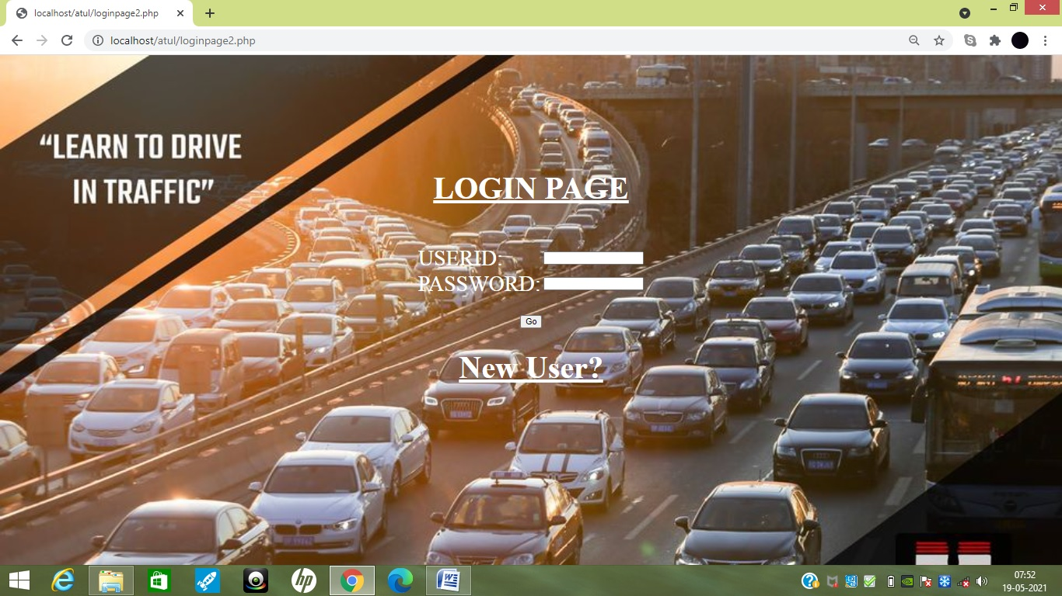

Batches Form:

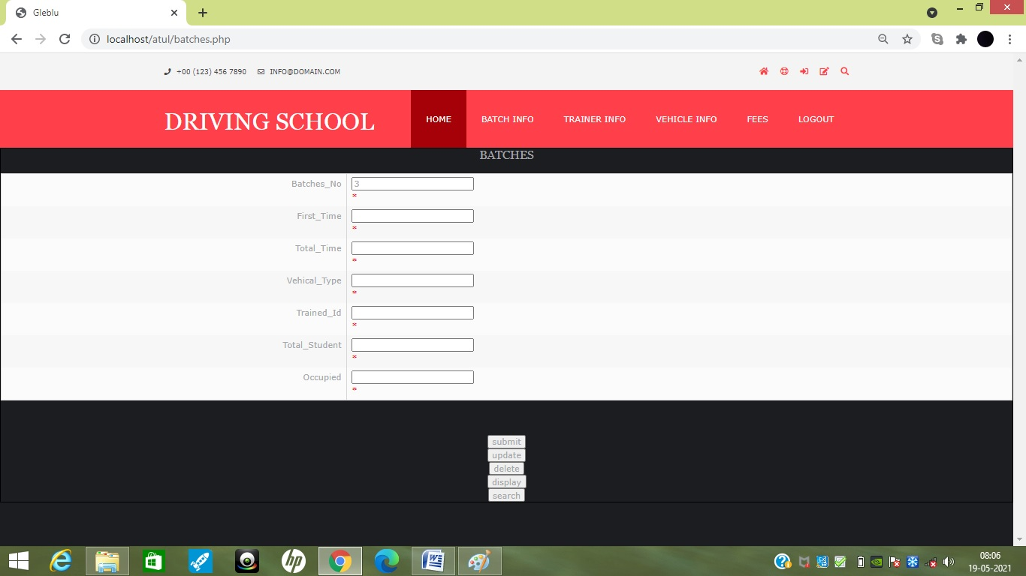

Trainer Form:

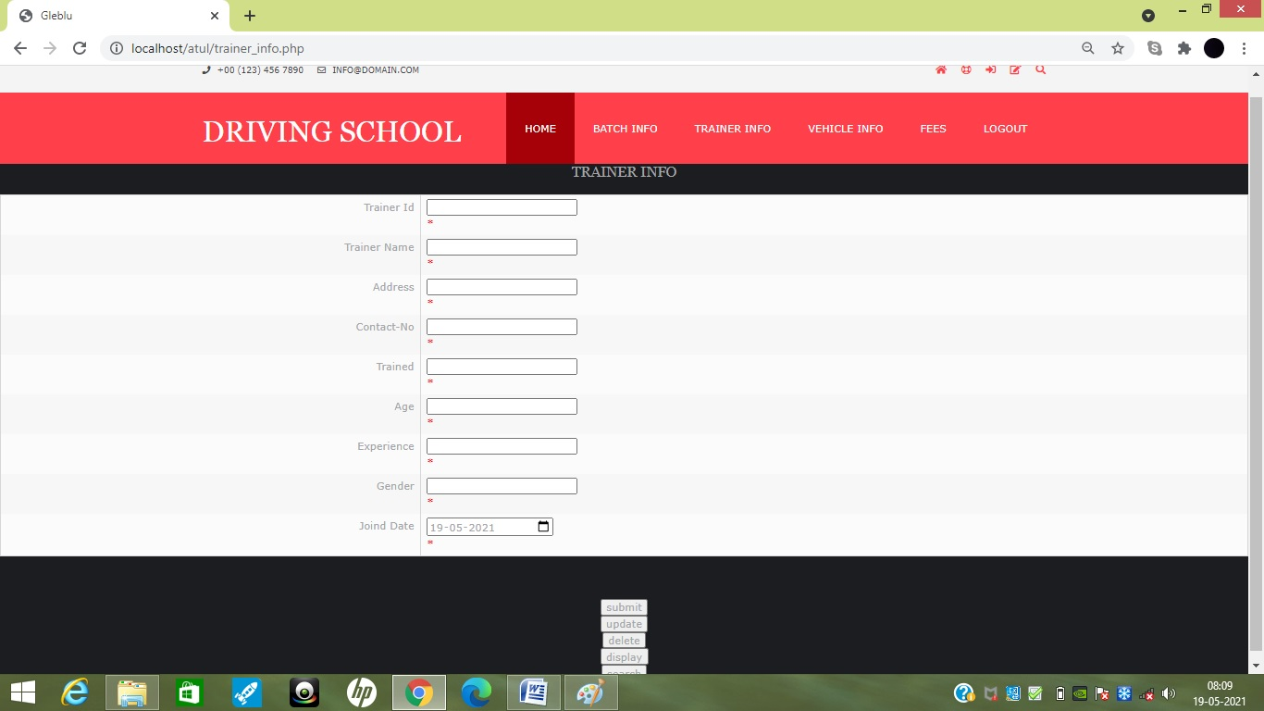

Vehical Form:

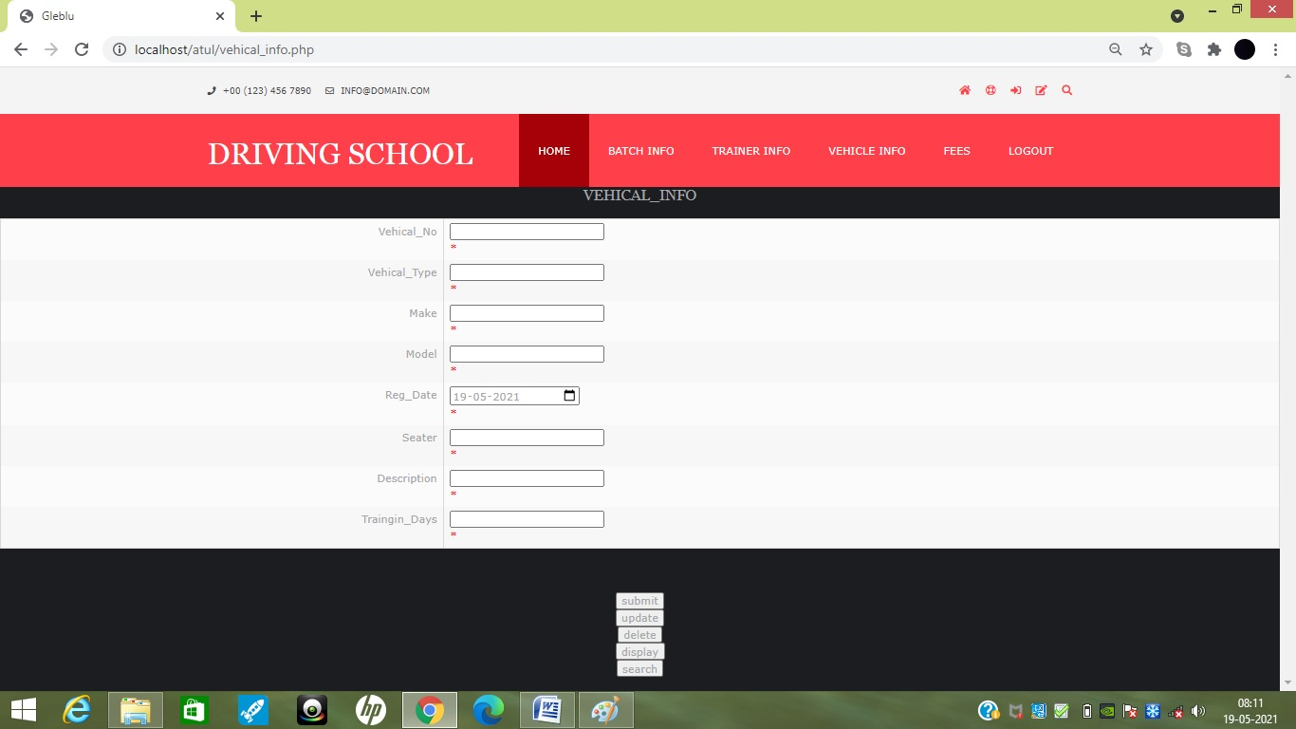

Fees Form:

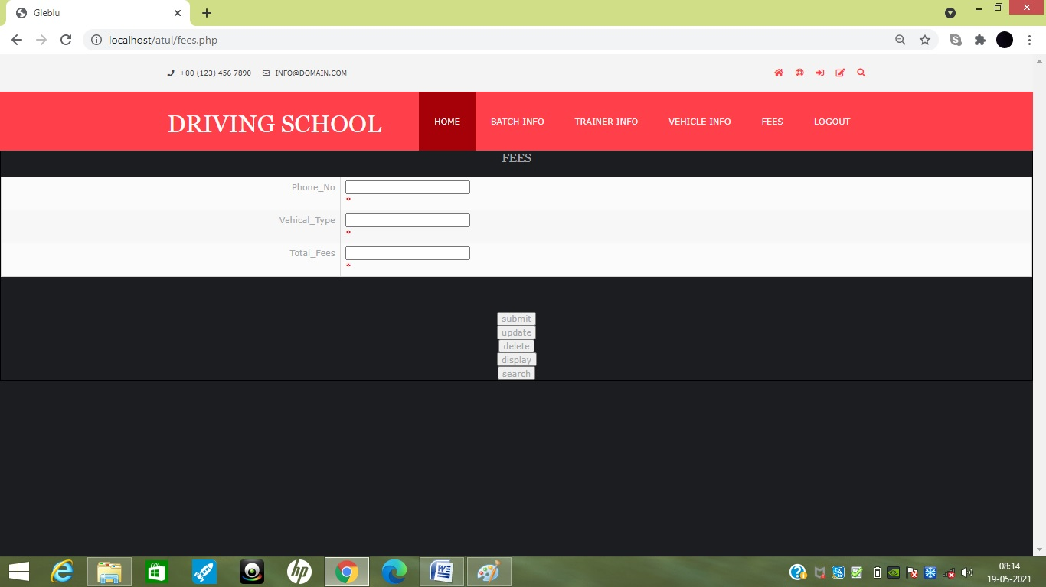

Student Form

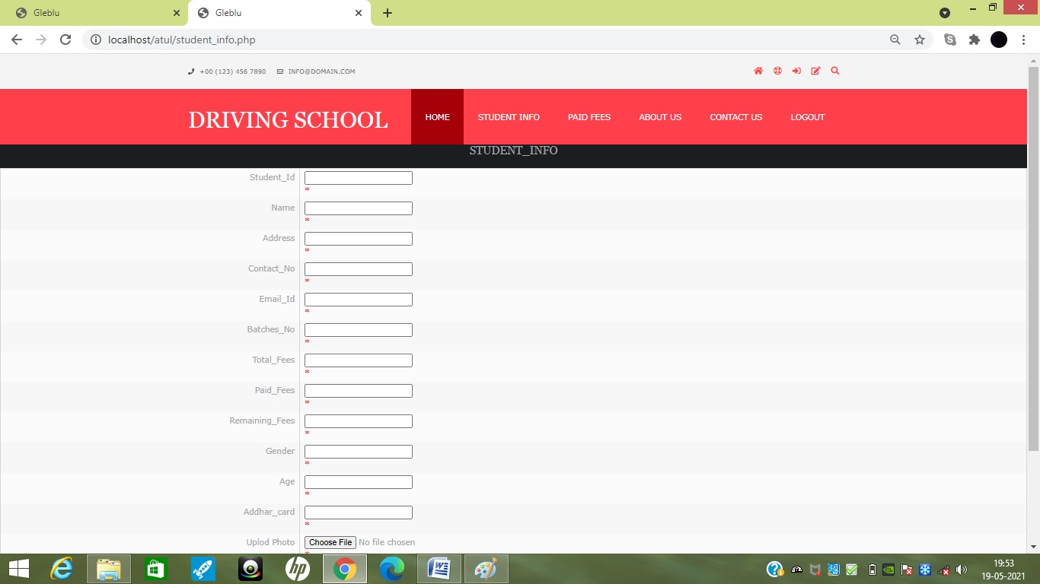

Paid Fees Form:

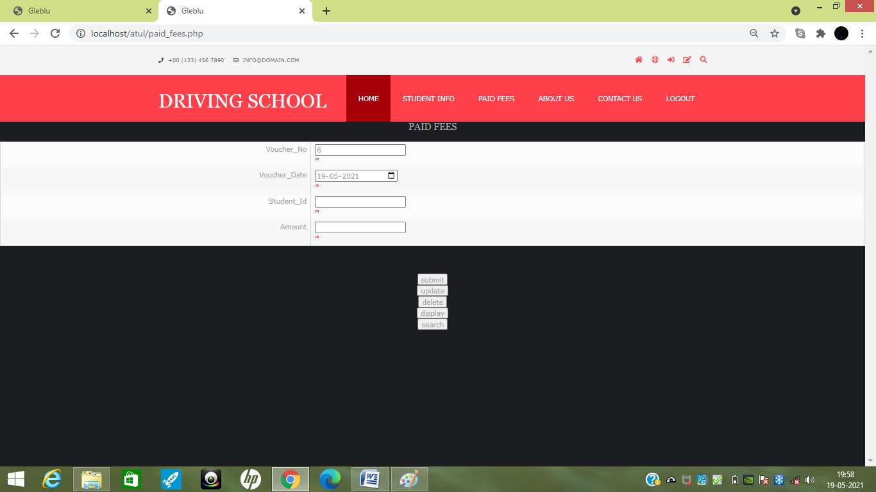

Batches Report:

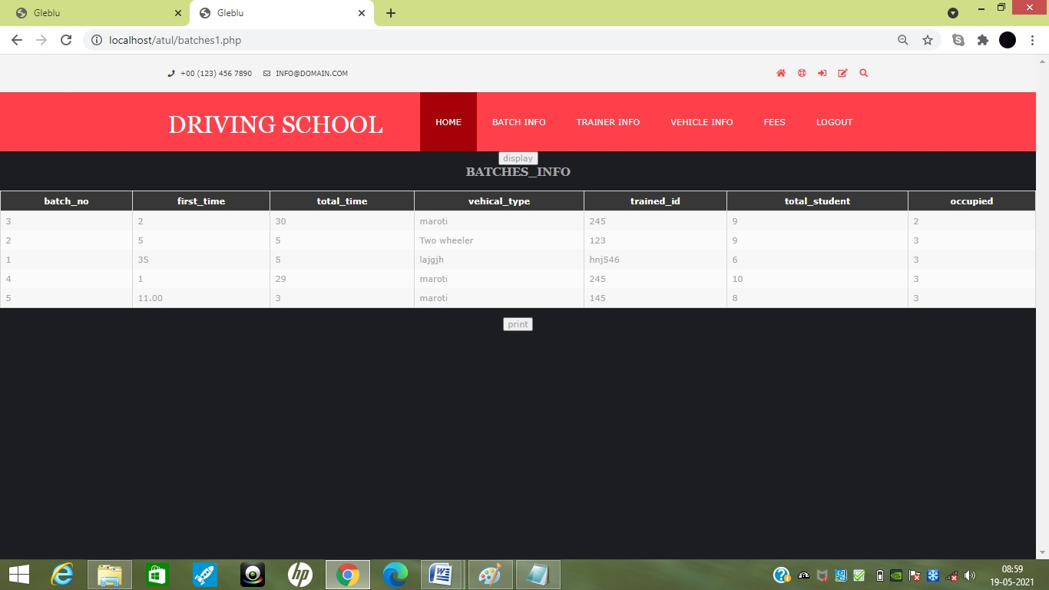

Trainer Report:

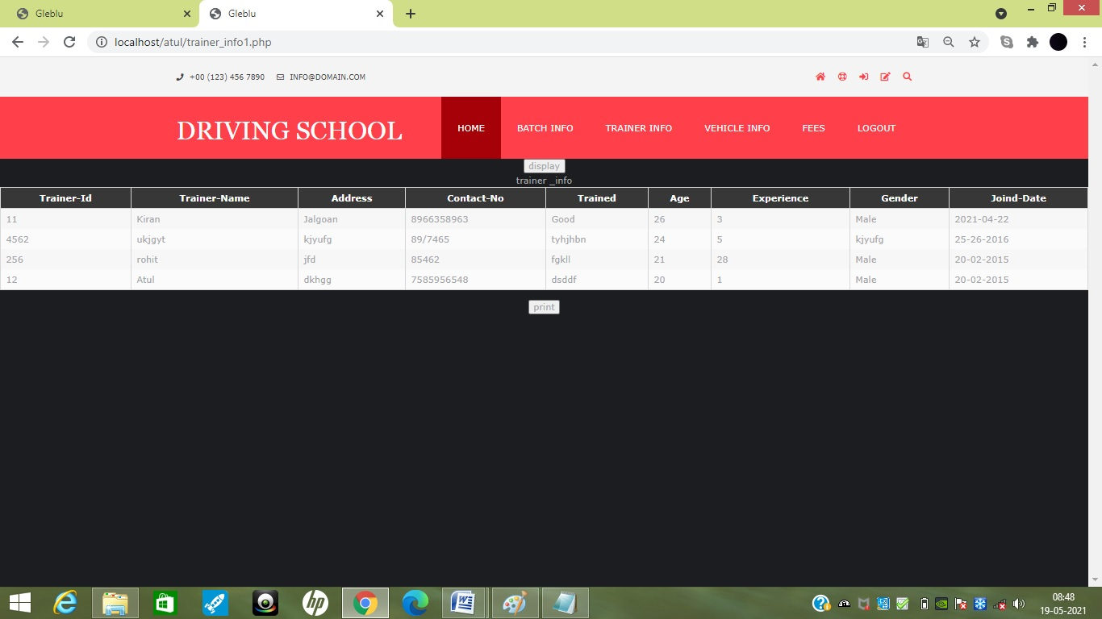

Vehical Report:

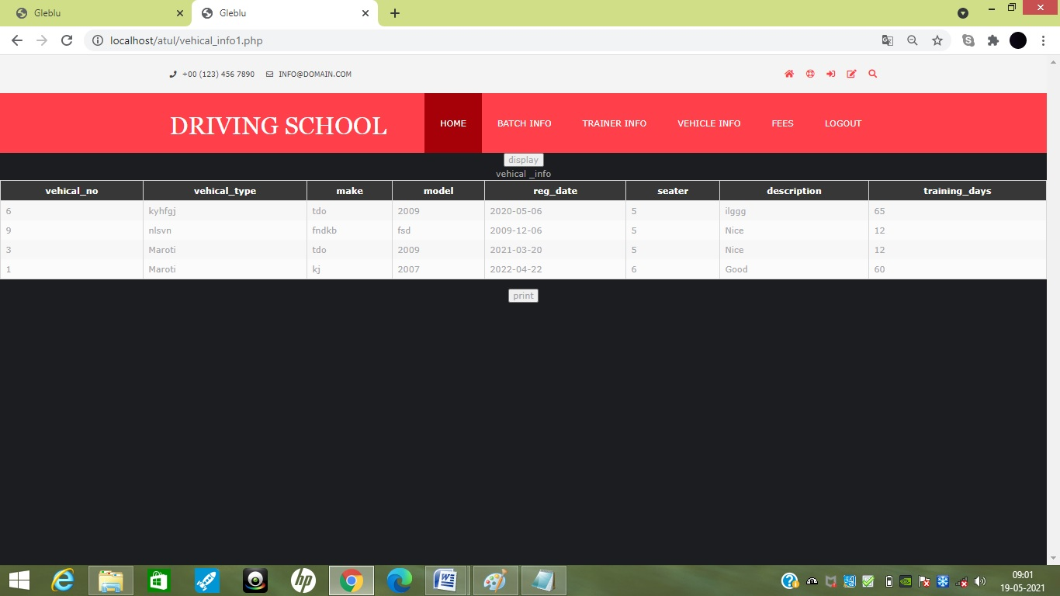

Fees Report:

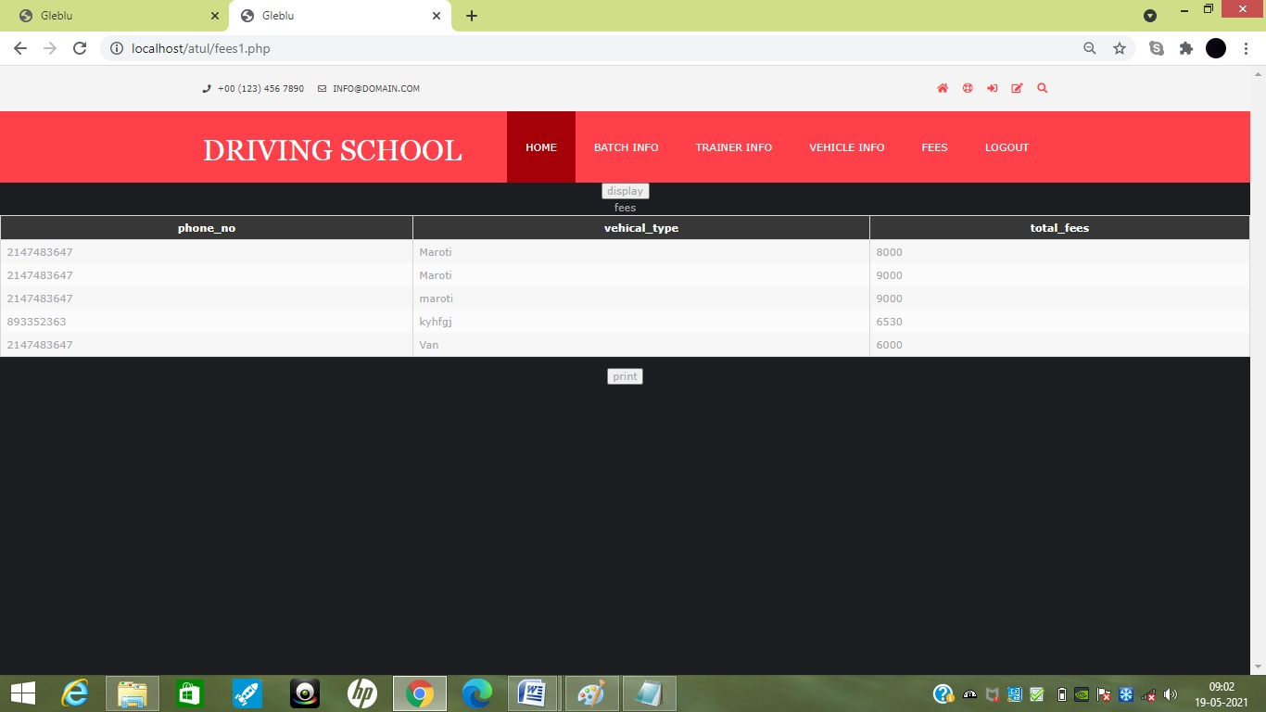

Student Report:

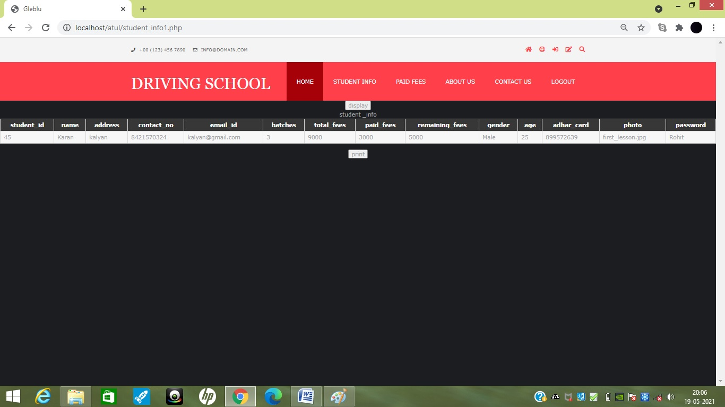

Paid Fees Report:

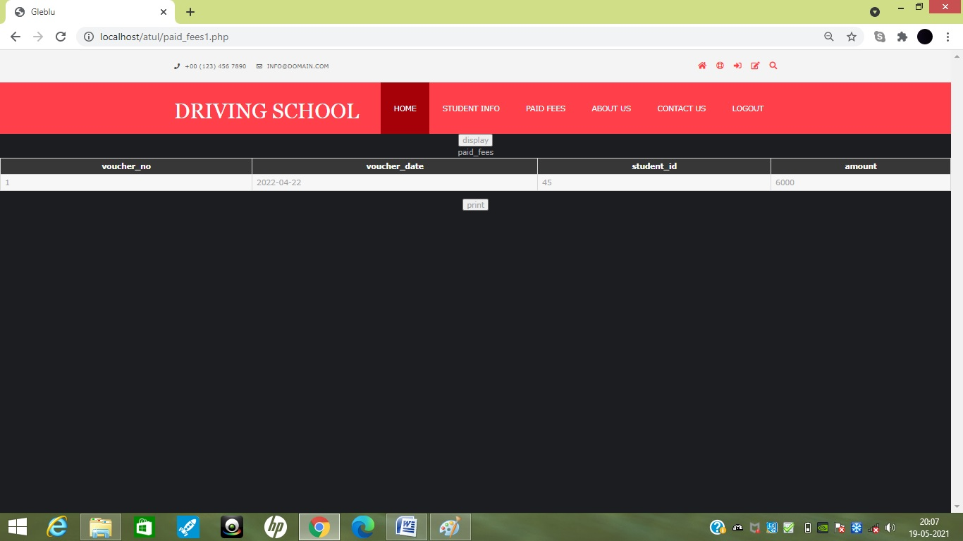

**CHAPTER 8**

**implementation**

**Implementation**-:

The activities of design development and implementation of SOFTWARE involved considerable resource and these are in terms of investment in hardware and software. These human efforts are measurable in persons when the SOFTWARE are expected to design it should considered the latest information technology.

SOFTWARE implementation has a modular approach. The overall implementation may be achieved within a span of 18 to 24 months or even more. In some organization, it is in accordance with a long range plan and well defined and a documented strategy. In many business organizations outside experts are involved in the preparation of long range SOFTWARE plan.

The implementation of SOFTWARE can be categorized in 4 categories as

1. Initial stage.
2. Partial achievement
3. Complete integration
4. First revamping completed.

**Events in SOFTWARE implementations-:**

1. Hardware platform selection
2. Selection of software tools
3. Activity charting and scheduling.
4. Resource allocation
5. Development and testing
6. Quality assurance, auditing and corrective action.
7. Documentation
8. User orientation
9. Configuration management.
10. System and database management.

The SOFTWARE implementation has 3 phases

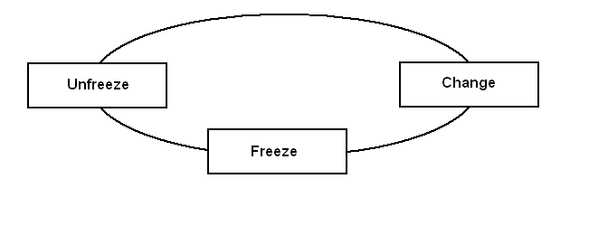

**Fig-: SOFTWARE implementation phase**

The diagram shows one of the techniques of implementation. The first phase is that “**Unfreeze**” in this phase all the required modification and changes to the existing procedure are identified. In the second phase “**Change**” the required modification are carried out. After the changes are implemented, the third phase “**Freeze**” is taken up. Hence all the procedure and practices are freeze and no changes are authorized unless the subsequent unfreezing is required.

**CHAPTER 9**

**Concluding Remark**

* **Strengths of system**
* Platform independent
* User friendly
* Graphical user interface
* Easy to customise
* System Administration module provide rights to user to create new user, to assign new

Roles to user, to assigns new privileges to user.

* Multiple user can access System simultaneously without loss of data.
* Both local and dollar currencies are used.
* Due to thin driver connectivity speed is improved.
* User can post operation charges to ledger account

## Limitations of system

* The system depends somewhat on the Network speed.
* There is need to improve presentation layer.

Pure object orientation is not implemented.

**Thank You**